**PLAYWRIGHT JS**

**PLAYWRIGHT JS AUTOMATION INSTALLATION STEPS**

**Step 1: Installing Playwright**

Visit the <https://playwright.dev/docs/intro>  
in that go to the installation section   
Terminal Command : npm init playwright@latest

**Sub Steps :**

**i)**Do you want to use Typescript/Javascript select which you want by default typescript will be selected  
**ii)**Specify the end-end test folder

**iii)**install the playwright browsers here or later by

executing terminal command :”npx playwright install”.  
**iv)**initializing the project package.json   
 run command :-“npm init -y”.

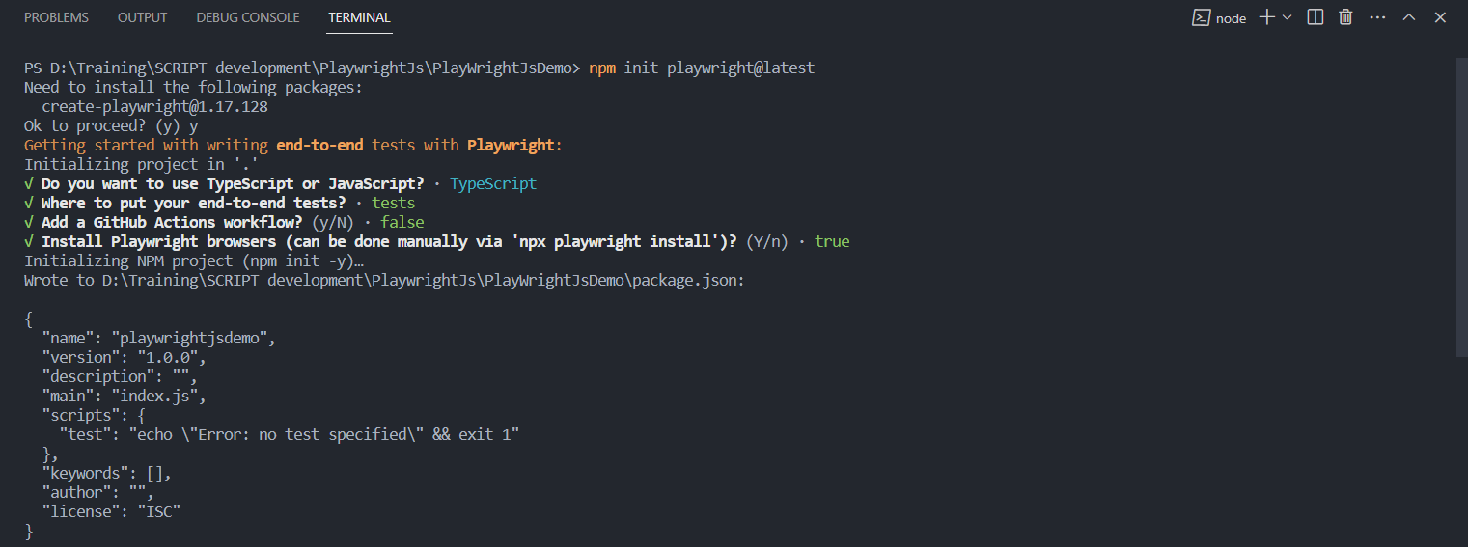

v)terminal command :-“npm install --save-dev @playwright/test”

this command will automatically install all the browser needs.  
 a) Chromium

b) Firefox nighty and normal firefox for the

c)webkit -safari  
all the dev dependencies will be written once you run the above mentioned terminal command.

**Note :-**other browser can be utilised by making changes in playwright.config.ts file.

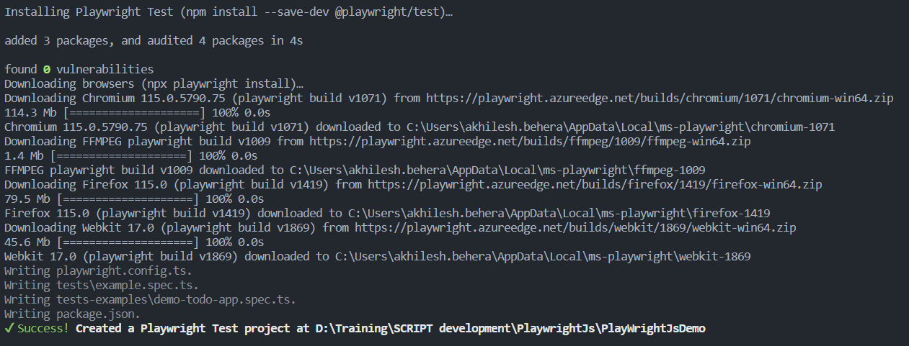

**Step 2: Running the Example Test**

Choice is yours its support both type script as well as normal JavaScript

Just add the spec.ts or test.js to test extension.

**Type 1**: All the test execution simultaneously using the below command.  
Terminal command: “ npx playwright test”  
**Type 2**: By default all the tests will execute in headless mode you have to run the tests in the headed mode.  
“npx playwright test --headed”  
**Type 3: “**npx playwright test --UI”  
it will execute the test in UI mode

**Type 4: “**npx playwright test --debug”  
**Type 5: “**npx playwright test --project=chromium”

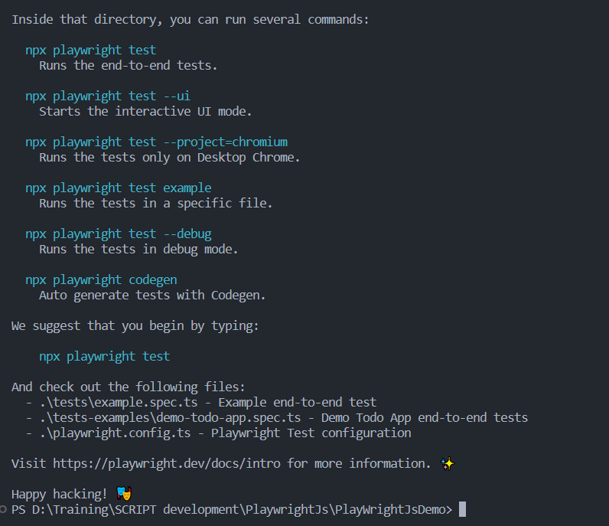

NOTE: -Difference between the NPX and NPM   
Node Package Manger & Node Package eXecute.

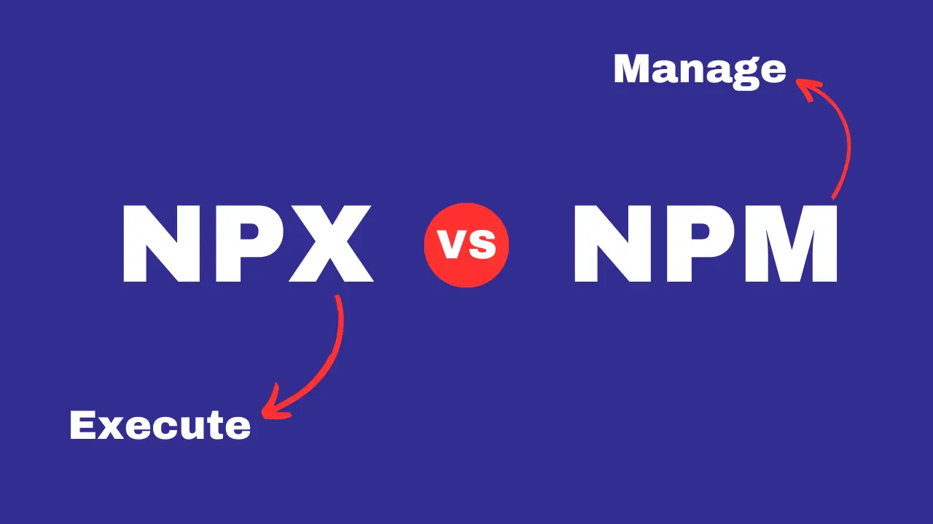

**How to take screenshot in Playwright JS:**

**Step 1:-** Make changes inside the playwright.config.ts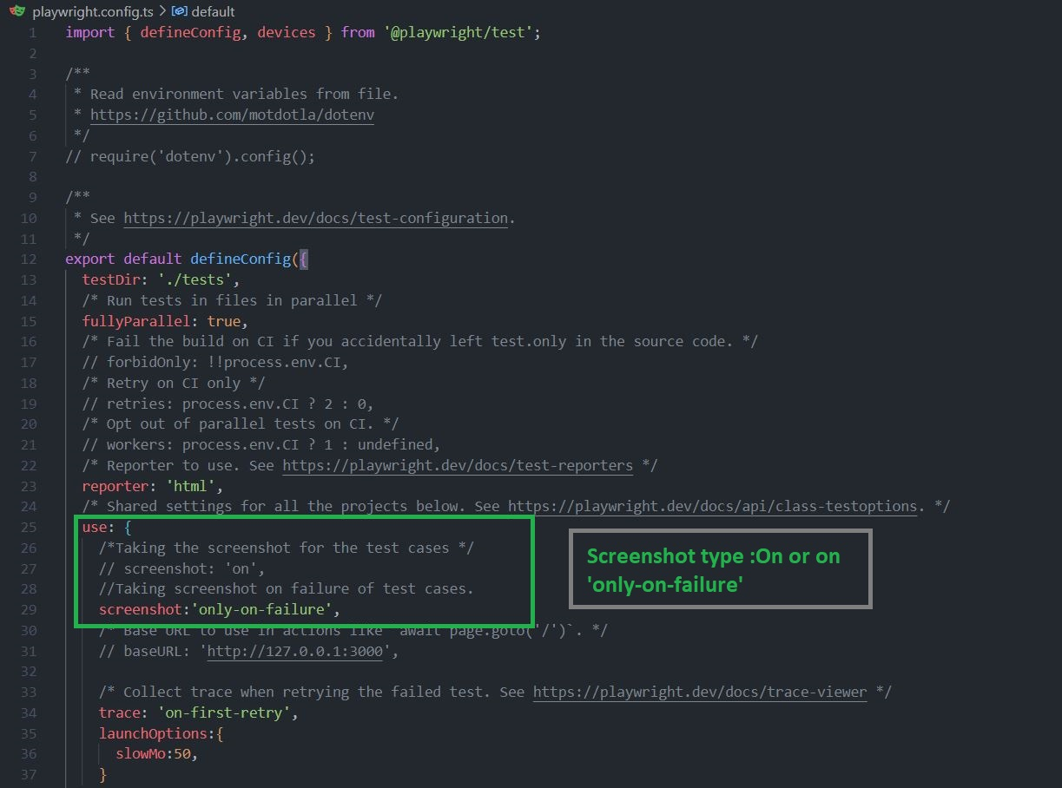

**Step 2**: - execute the script using the terminal   
Terminal Command:-“ npx playwright test dealscrapping .test.js --headed”.

**Step 3:** - when you open the report in web browser it will open the screenshot attached to the html report

**How to Maximize The window in playwright**

**First Way – Via playwright.config file**

1. Add args: ["--start-maximized"] to the launchOptions
2. Remove the DeviceDescriptor from your project
3. Set viewport: null in your project

Example playwright.config.ts file:

// playwright.config.ts file

import { defineConfig, devices } from "@playwright/test";

export default defineConfig({

use: {

launchOptions: {

// 1

args: ["--start-maximized"],

},

},

projects: [

{

name: "chromium",

use: {

// 2 (Make sure device is not set)

// ...devices["Desktop Chrome"],

// 3

viewport: null,

},

},

],

});

**Second Way - In the test itself**

const browser = await chromium.launch({

headless: false,

args: ["--start-maximized"],

});

const context = await browser.newContext({ viewport: null });

const page = await context.newPage();

Again, note that you follow these steps:

1. Add args: ["--start-maximized"] to the launchOptions
2. Remove the DeviceDescriptor from your project configuration
3. Set viewport: null in the BrowserContext

**TEST TIMEOUT**  
Note:- As playwright JS execution lightning Fast

To understand & to show case the steps we need to slow down the test steps to see what’s going on beneath the Test step Execution.

use: {

/* Collect trace when retrying the failed test. See https://playwright.dev/docs/trace-viewer */

    trace: 'on-first-retry',

    launchOptions:{

      slowMo:50,

    }

  },

**slowMo**: Desired milliseconds for the execution to delay in every step. Example:- 50 ms each click of steps.

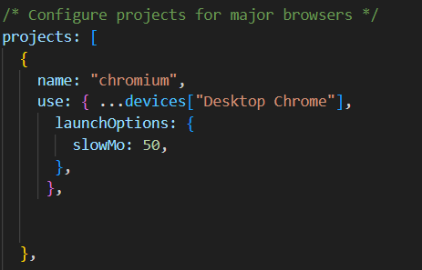  
***It will be useful in the presentation of Automation Script.***  
Note:-Before every test the timeout will be applicable before test.  
In every test test .setTime out for each test.

test.beforeEach(async ({ page }, testInfo) => {

    // Extend timeout for all tests running this hook by 30 seconds.

    testInfo.setTimeout(testInfo.timeout + 30000);

  });

test("Run in Android - Chrome", async () => {

    // Connect to the device.

    test.setTimeout(120000);

***set time out -1000ms is 1 sec***

**Parallel Test in Playwright   
@Tags**

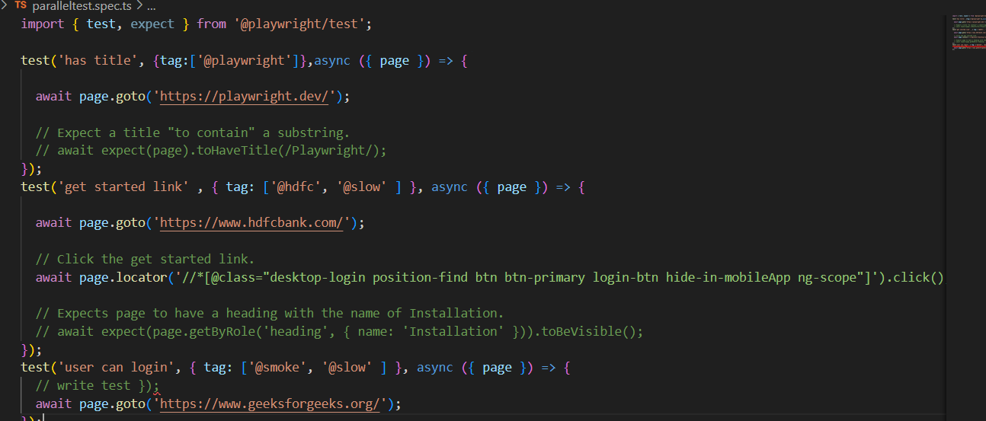

**Cmd Terminal commands:-**  
npx playwright test --grep "@hdfc"

npx playwright test --grep "@hdfc" --headed

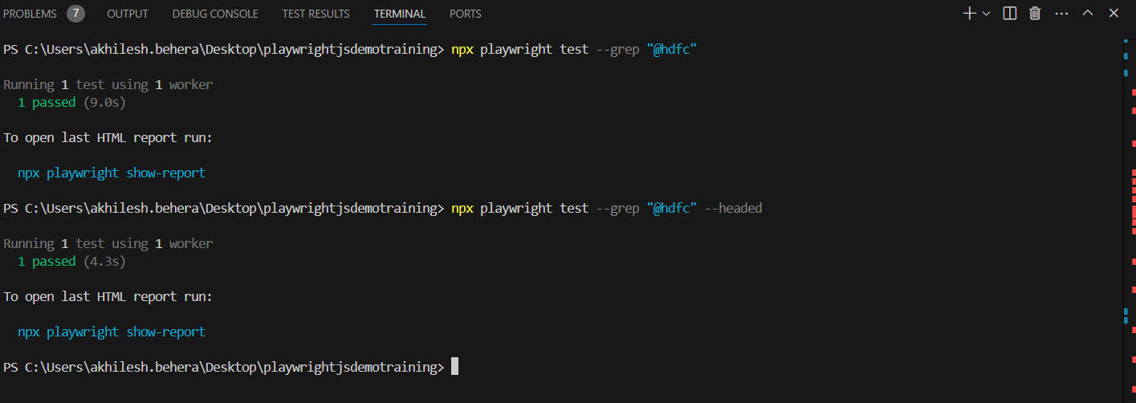

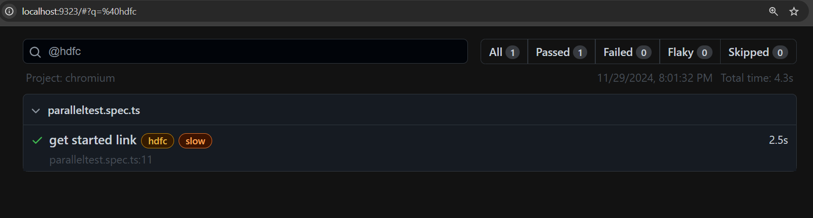

**Playwright Test tool for Test run execution**

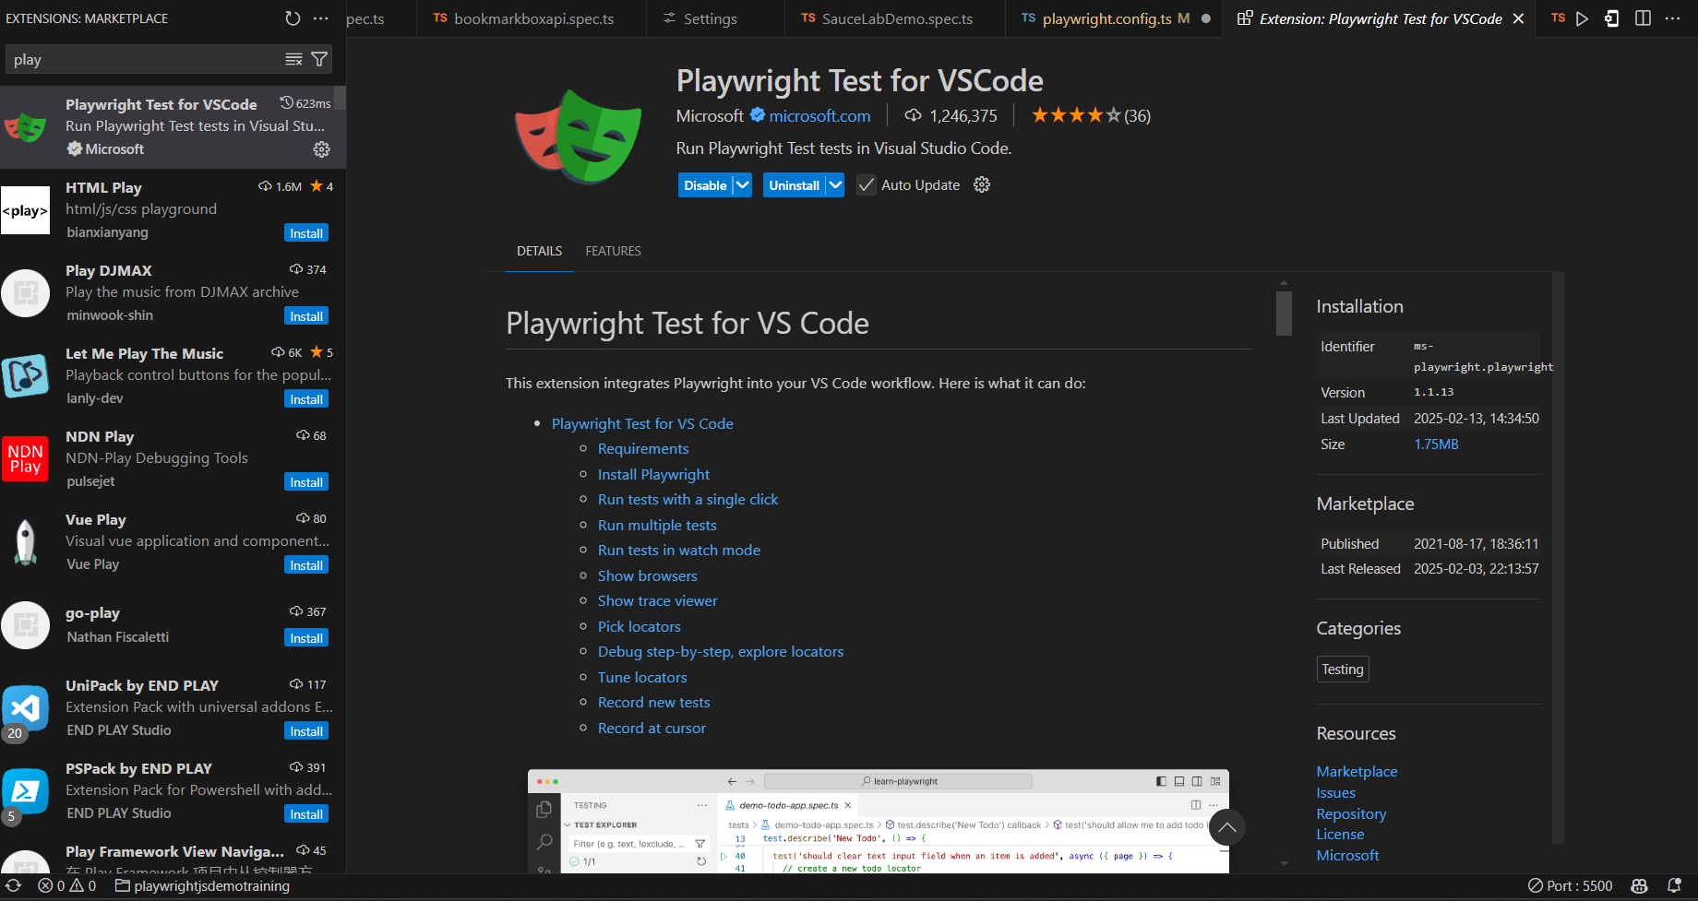  
  
  
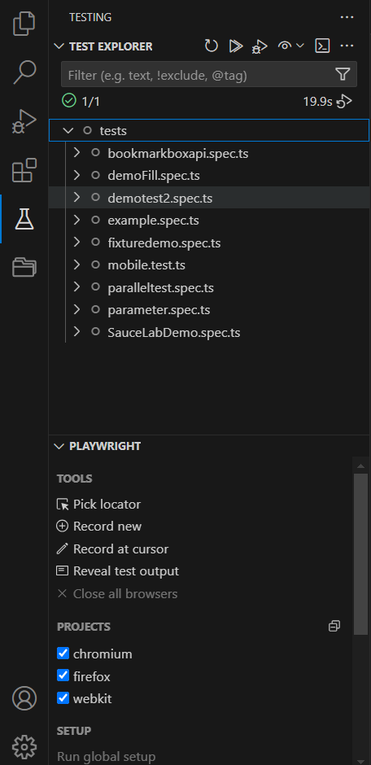

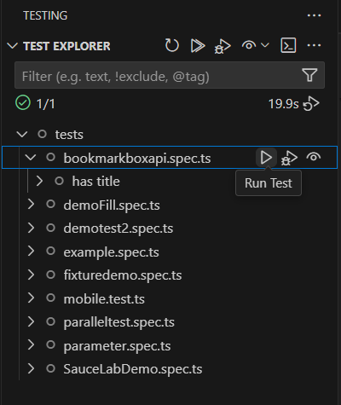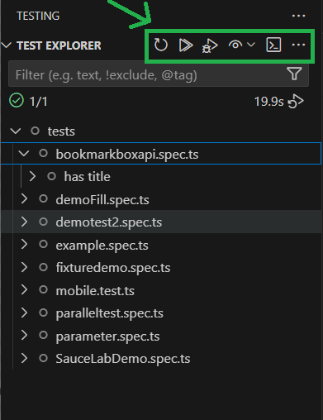  
  
  
***PLAYWRIGHT JS ANDROID MOBILE TESTING   
Step 1 :- Install the Android studio giraffe from official website.***

Website Url:- <https://developer.android.com/studio>

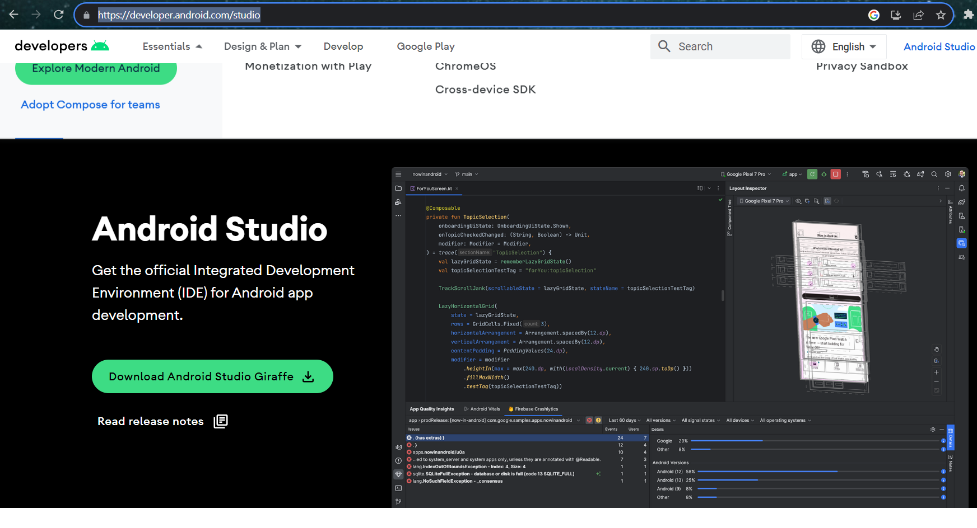  
**Step 2:-**Then install the emulator with the API 34 android Version for emulator

Website Url:- <https://developer.android.com/studio/run/managing-avds>

**Step3 :-**Install the Intel HAXM to run the Emulator with any hardware issue the emulator will render properly

Step 4: Setup environment variable set inside the path under the Environment variable setup under the Advance account settings

i)Android Sdk path:-

“C:\Users\Administrator\AppData\Local\Android\Sdk”

ii) Android Home path

“C:\Users\akhilesh.behera\.android”

iii) Android emulator path

“C:\Users\akhilesh.behera\AppData\Local\Android\Sdk\emulator”

iv)Android Build tools path

“C:\Users\Administrator\AppData\Local\Android\Sdk\build-tools”

v)Java path should be set inside the path under the Environment variable setup under the Advance account settings   
v)Now set the node home path

“C:\Program Files\nodejs”

vi)Node/ modules path

“C:\Program Files\nodejs\node_modules”

**For the setting inside the VS CODE:-**

1)Download the Playwright Test for VSCode Tool inside the marketplace of the VS Code

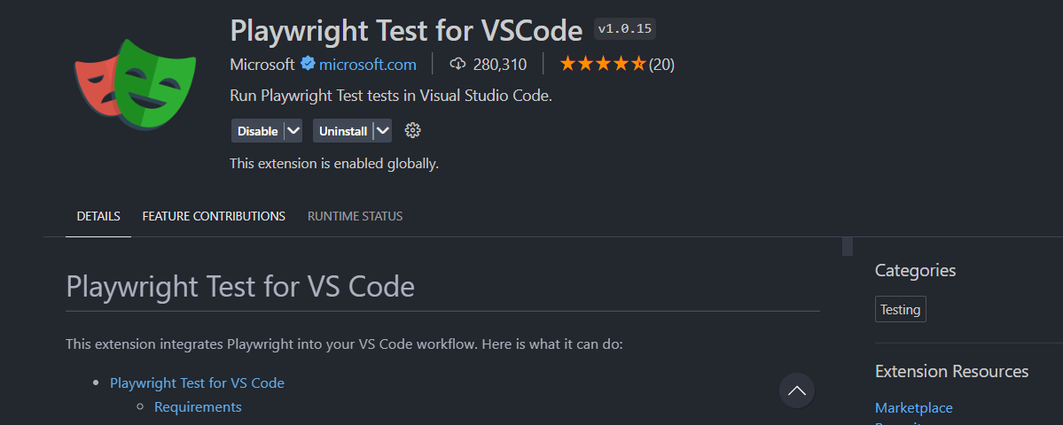

2)Android iOS Emulator   
  
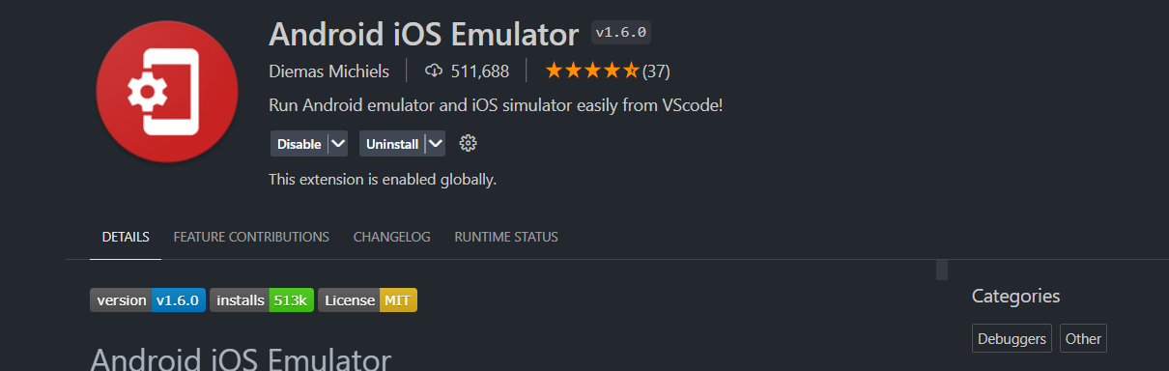

Android iOS Emulator settings for the emulator that we have created using android Studio. Give the emulator path.

Emulator path: by default:- ~/Library/Android/sdk/emulator

**Emulator path for windows will be: -** “C:\Users\akhilesh.behera\AppData\Local\Android\Sdk\emulator”

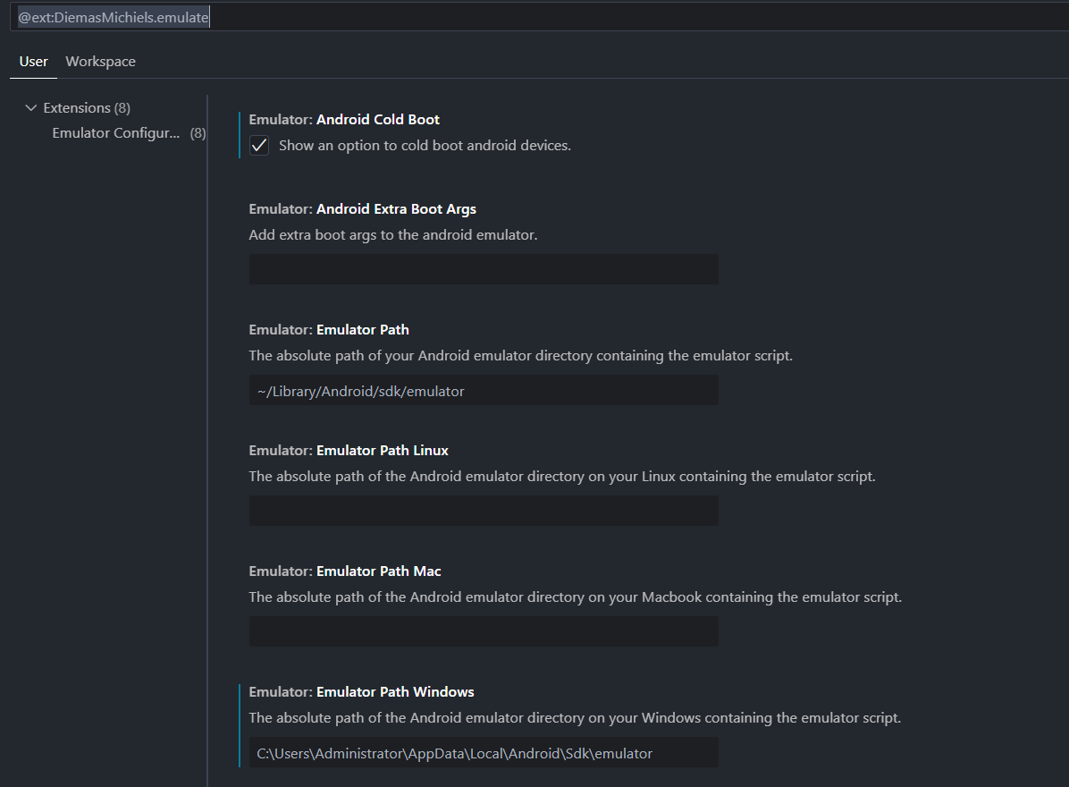

**Mobile Emulator start from the VS code studio.**

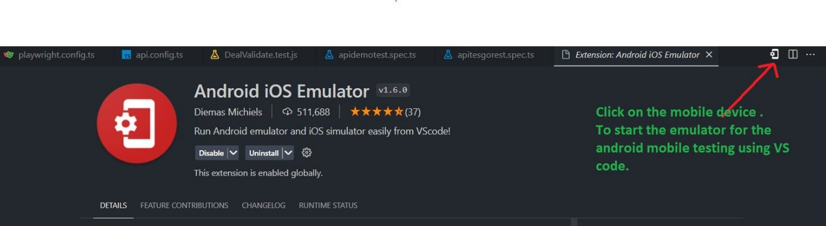

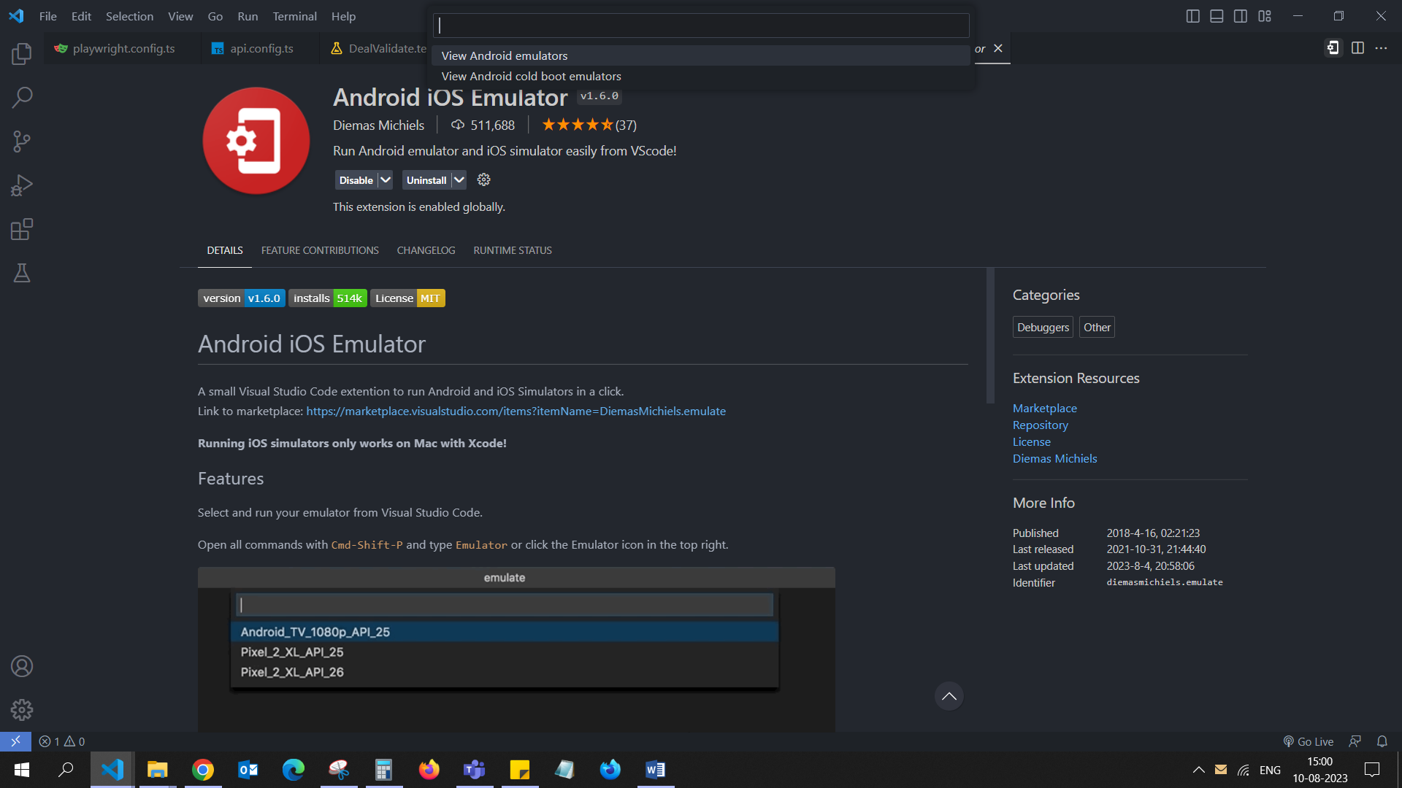

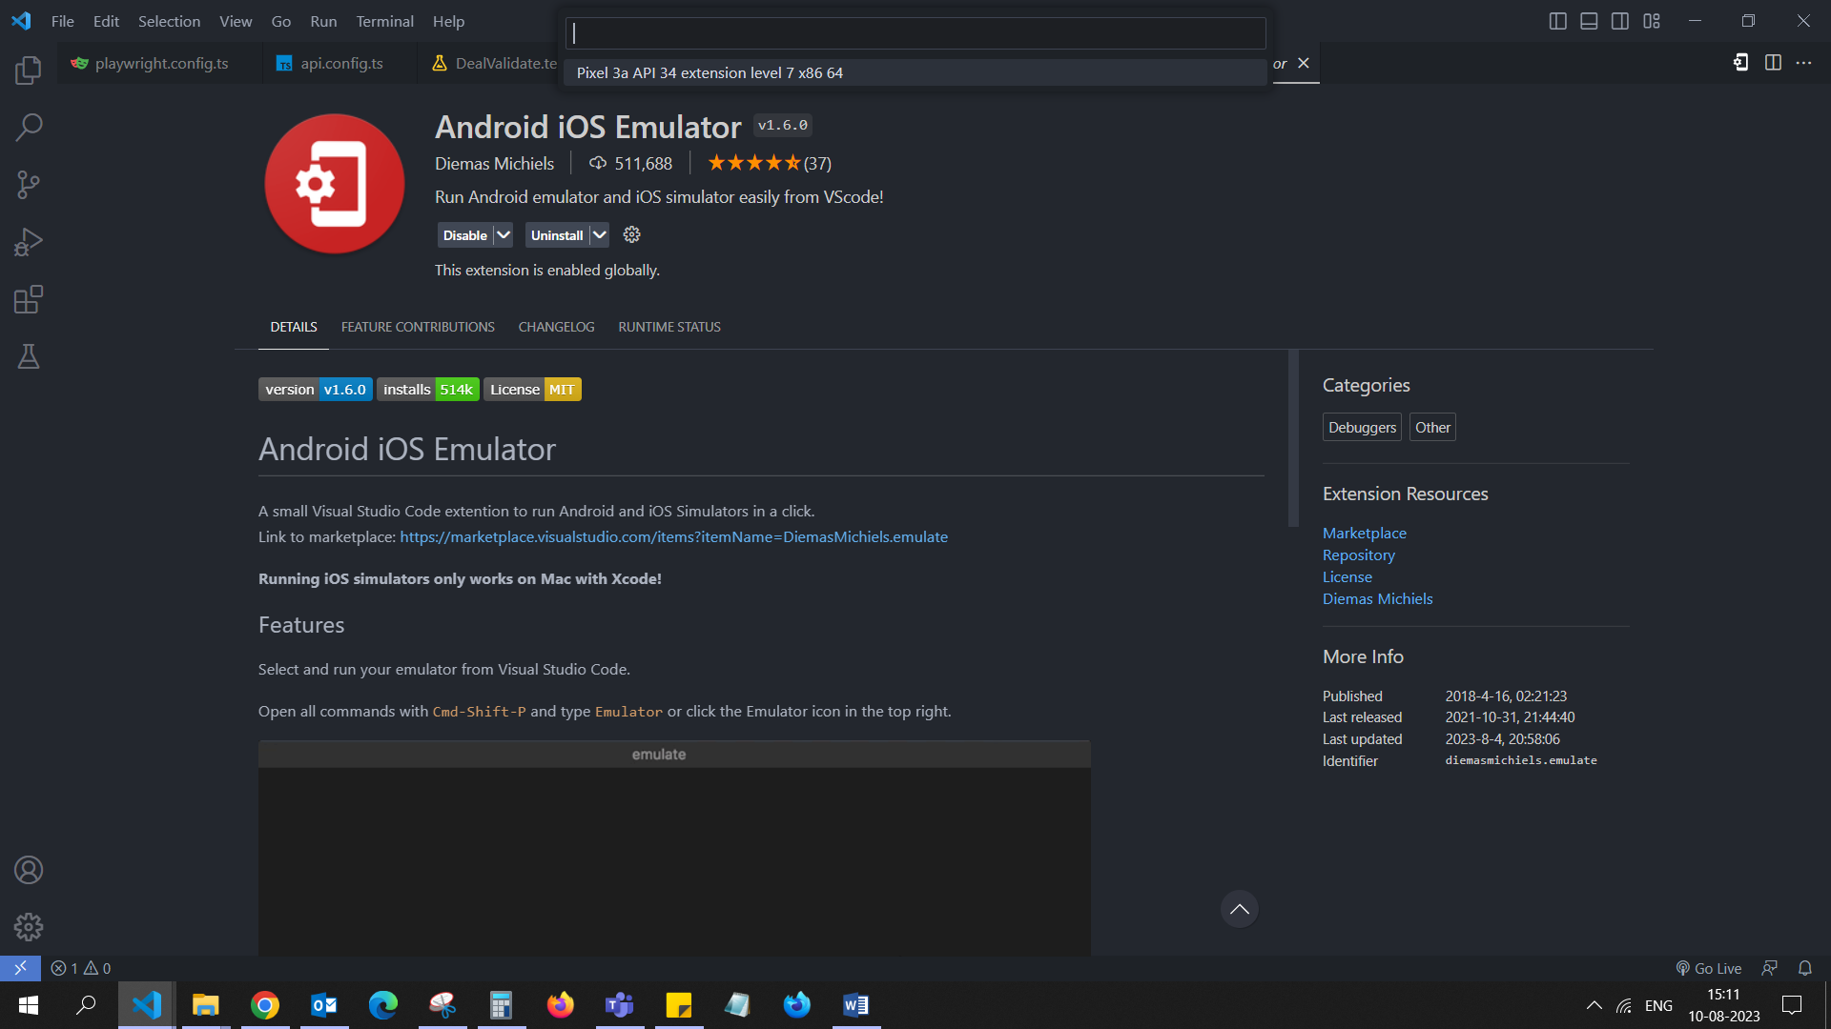

**Emulator starting state:-**

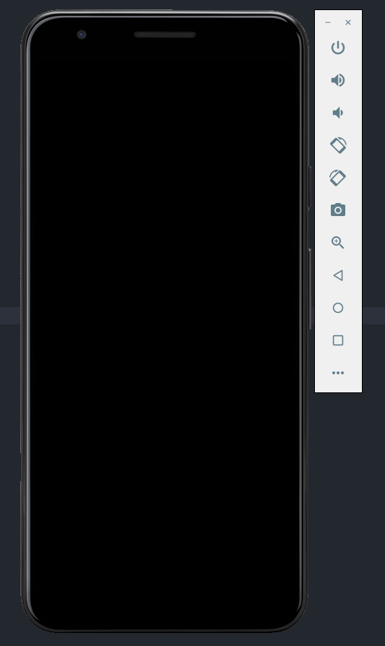

Emulator boot the android device Successfully.

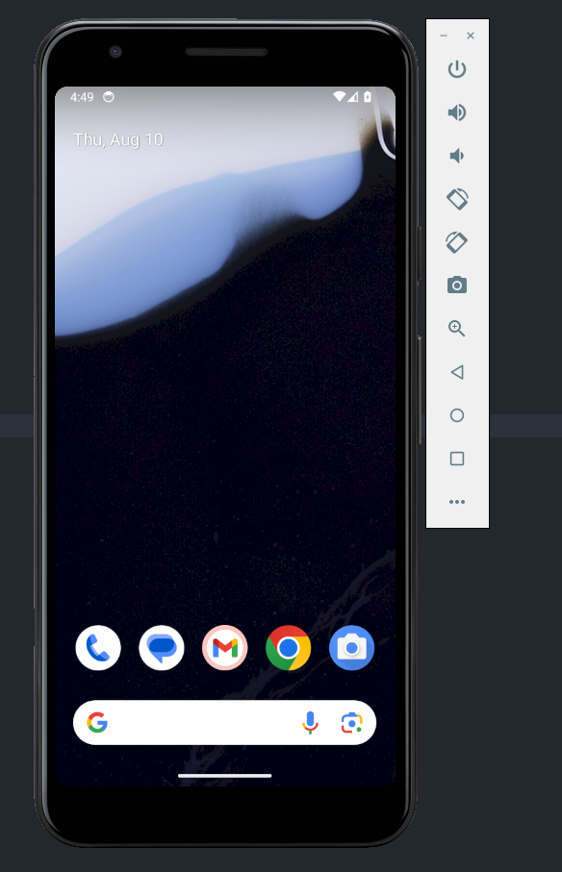

**HOW TO PERFORM THE MOBILE TESTING ON ANDROID**

**Step 1:-**Follow above steps to start the emulator in VS code.

**Step 2:-**Wait until emulator starts then click on the emulator window.

**Emulator is booting up the android device**

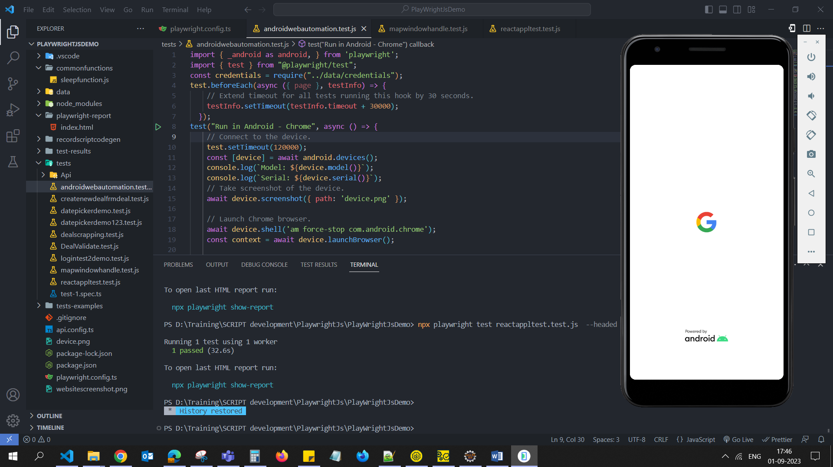

**After emulator booted the android device in ready state home page of android device is visible then you can start executing the script.**

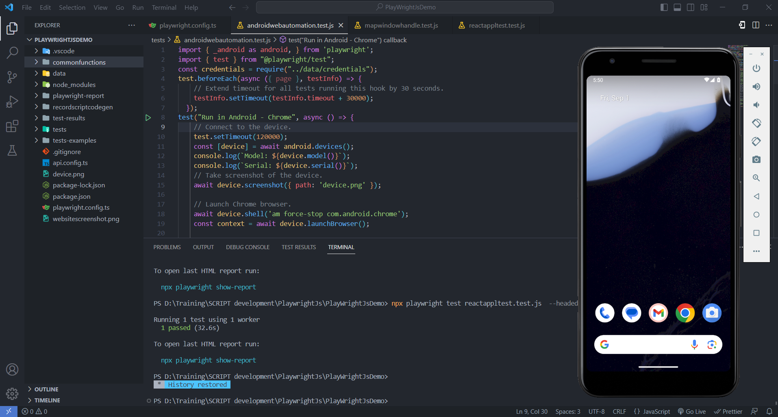

**STEP 3:-**

Now start the test execution.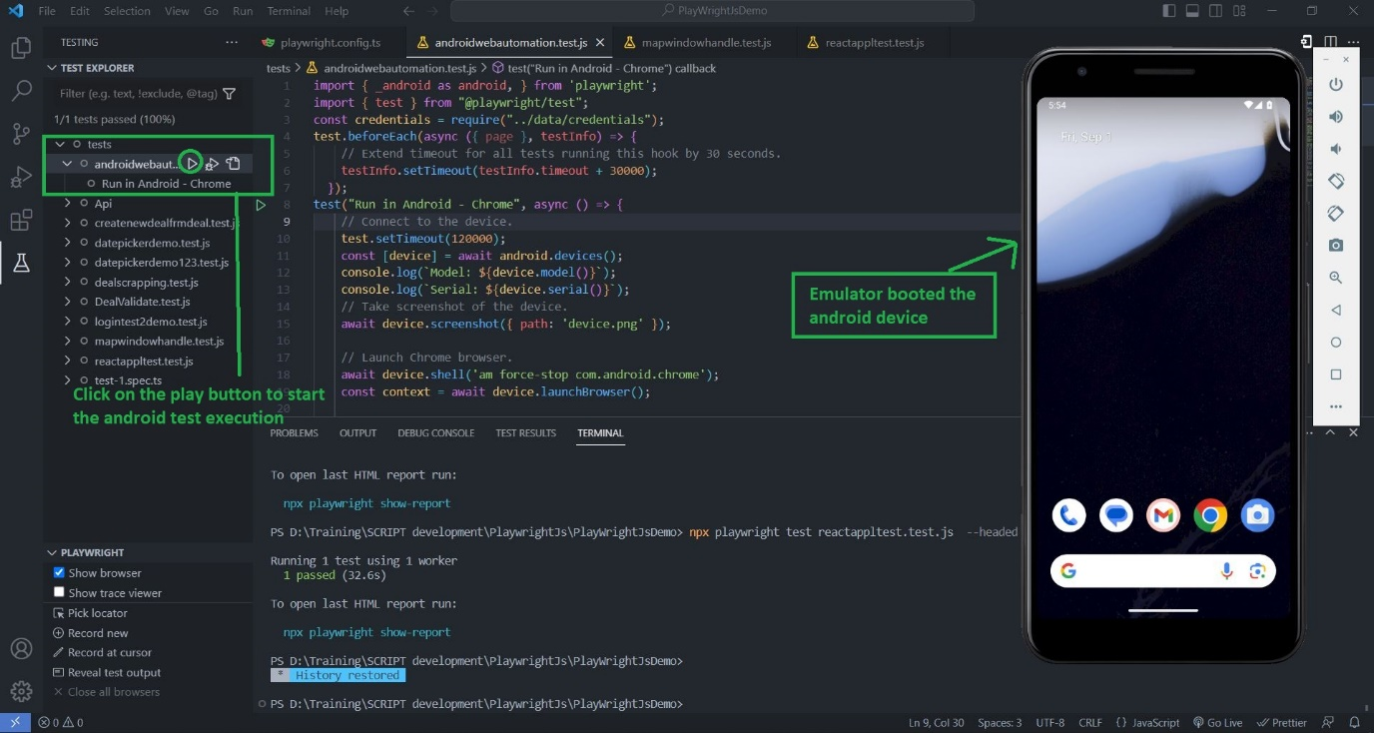

Sample Demo script to test android web automation with chrome mobile browser.

**SAMPLE SCRIPT FOR ANDROID MOBILE TESTING:-**

import { _android as android, } from 'playwright';

import { test } from "@playwright/test";

test.beforeEach(async ({ page }, testInfo) => {

    // Extend timeout for all tests running this hook by 30 seconds.

    testInfo.setTimeout(testInfo.timeout + 30000);

  });

test("Run in Android - Chrome", async () => {

    // Connect to the device.

    test.setTimeout(120000);

    const [device] = await android.devices();

    console.log(`Model: ${device.model()}`);

    console.log(`Serial: ${device.serial()}`);

    // Take screenshot of the device.

    await device.screenshot({ path: 'device.png' });

    // Launch Chrome browser.

    await device.shell('am force-stop com.android.chrome');

    const context = await device.launchBrowser();

    // Use BrowserContext as usual.

    const page = await context.newPage();

    // await page.goto('https://en.m.wikipedia.org/wiki/Main_Page');

    await page.goto('https://trainee-web-app.azurewebsites.net/auth/login');

 // close context and device

    await context.close();

    const contextscreen = await device.screenshot({ path: 'websitescreenshot.png' });

    await device.close();

}

**Step 5: -** once you click the test play button then the execution of the test will start executing the test functionality.

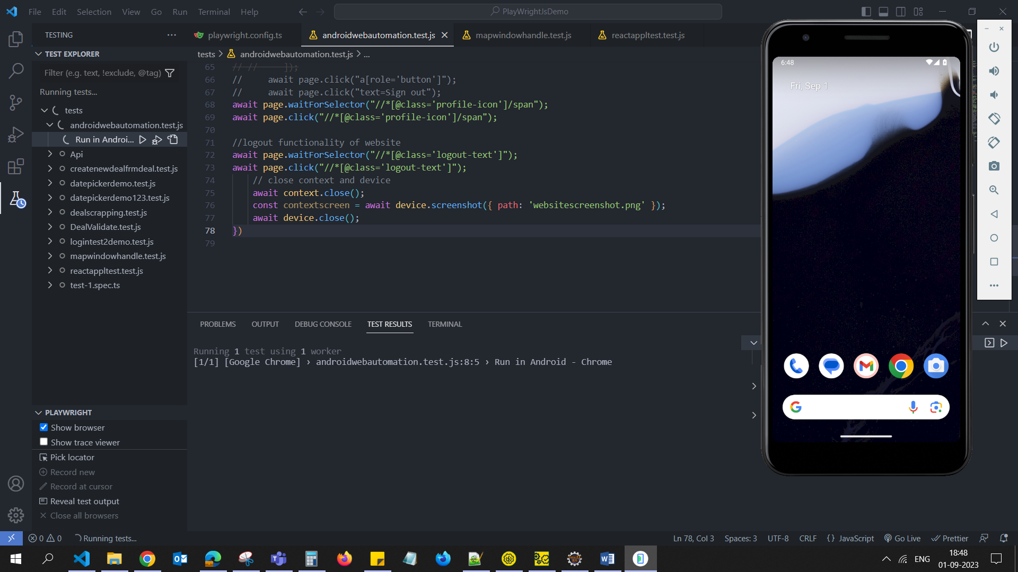

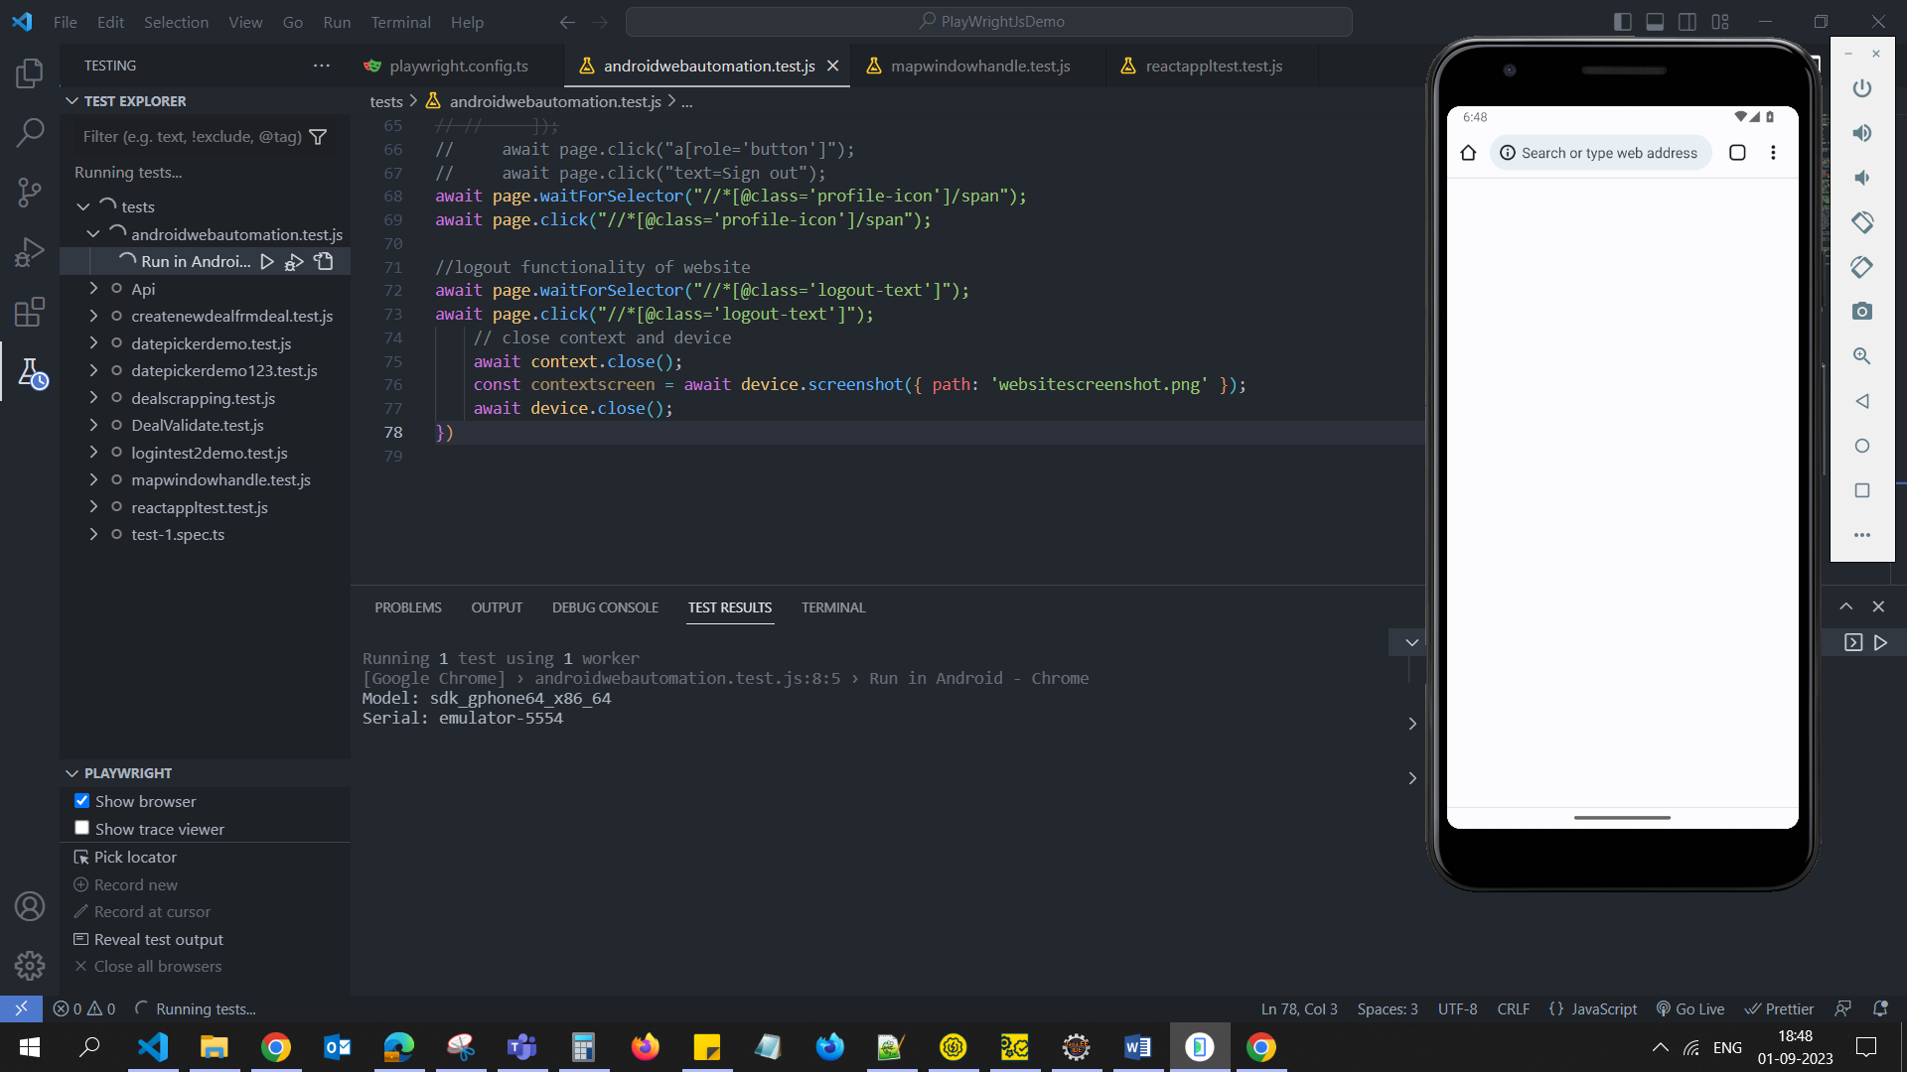

Success!! In opening the URL in emulated mobile android device.

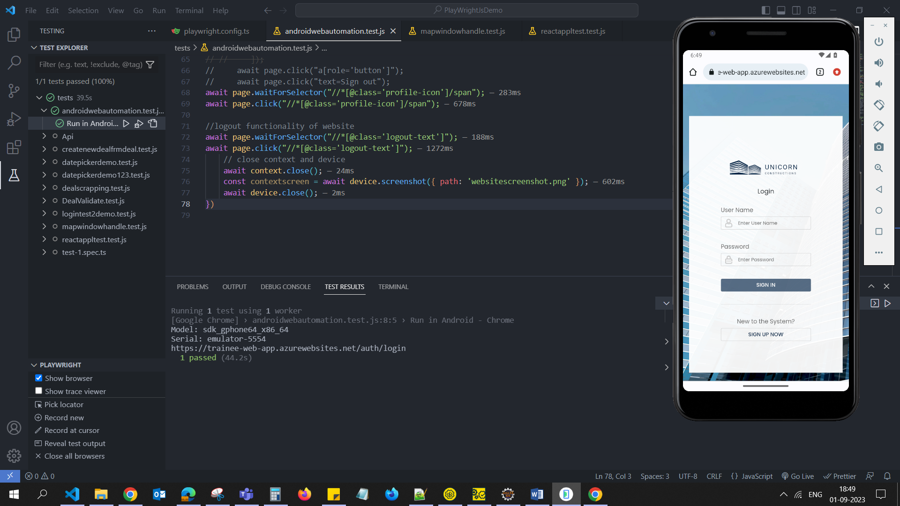

**REACT APPLICATION TEST :-**  
**Step 1:-** Install the Chrome Extension for the React Developer Tool  
its use case is to verify the whether the web application is react or not.  
 Extension url :- <https://chrome.google.com/webstore/detail/react-developer-tools/fmkadmapgofadopljbjfkapdkoienihi/related>

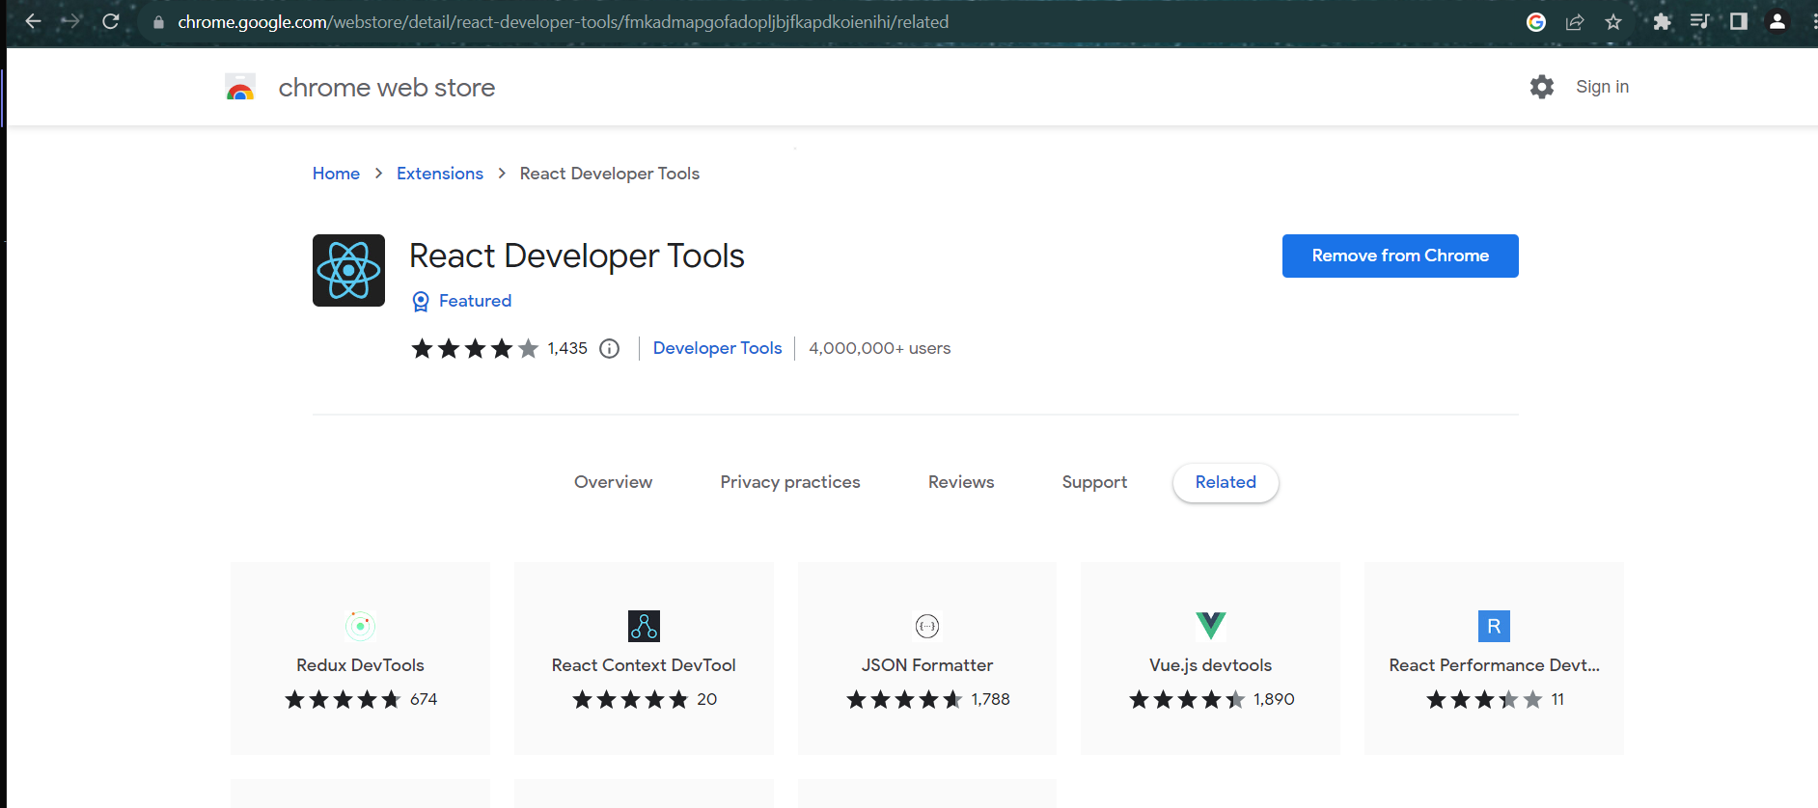

**Step2** :- proceed to react application like [react offical website](https://react.dev/), [Netflix](https://www.Netflix.com), Facebook ,[dropbox](https://www.googleadservices.com/pagead/aclk?sa=L&ai=DChcSEwiTiuvRzfeAAxXJlUsFHbLDDIMYABAAGgJzZg&gclid=EAIaIQobChMIk4rr0c33gAMVyZVLBR2ywwyDEAAYASAAEgITcvD_BwE&ohost=www.google.com&cid=CAASJuRoeNtNcRKLRnJlPB7tvzQZXM19WMrwuapfLJG_zT6h4a6Ur8Wo&sig=AOD64_1qqzW6nGPwtP623qSfdhjy4f5h6w&q&adurl&ved=2ahUKEwi08uTRzfeAAxVN3TgGHehBBP4Q0Qx6BAgGEAE) ,[NY Times](https://www.nytimes.com/international/) top website these are few that are developed in react.

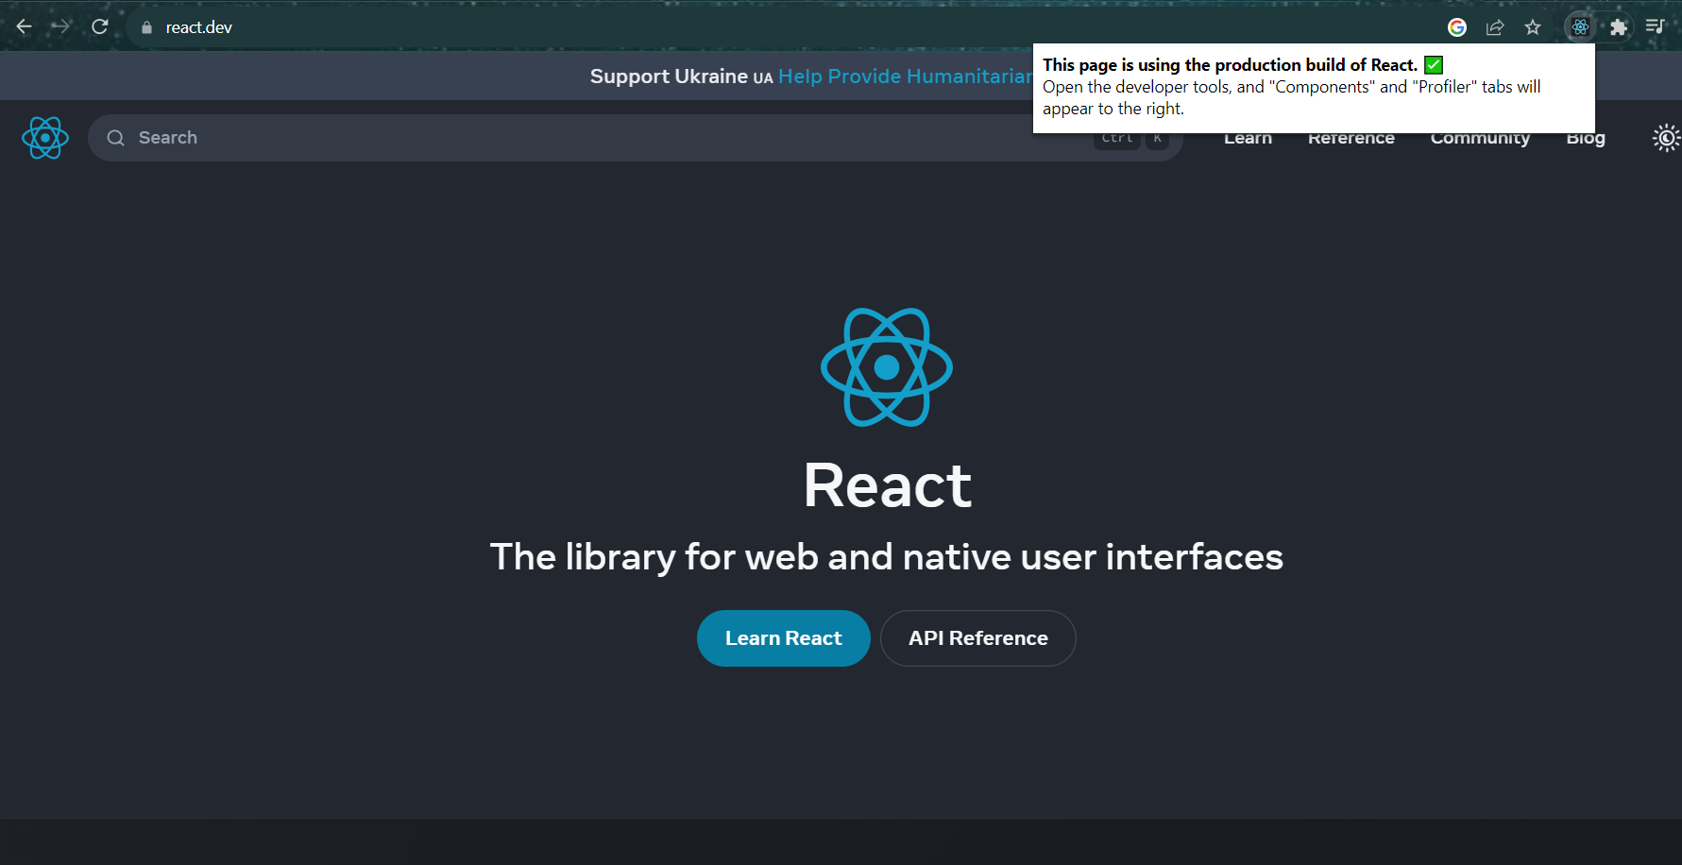

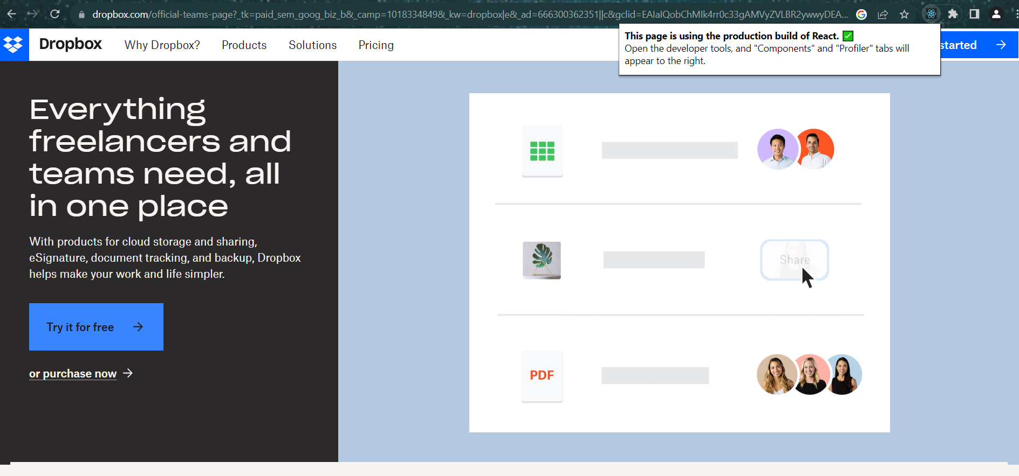

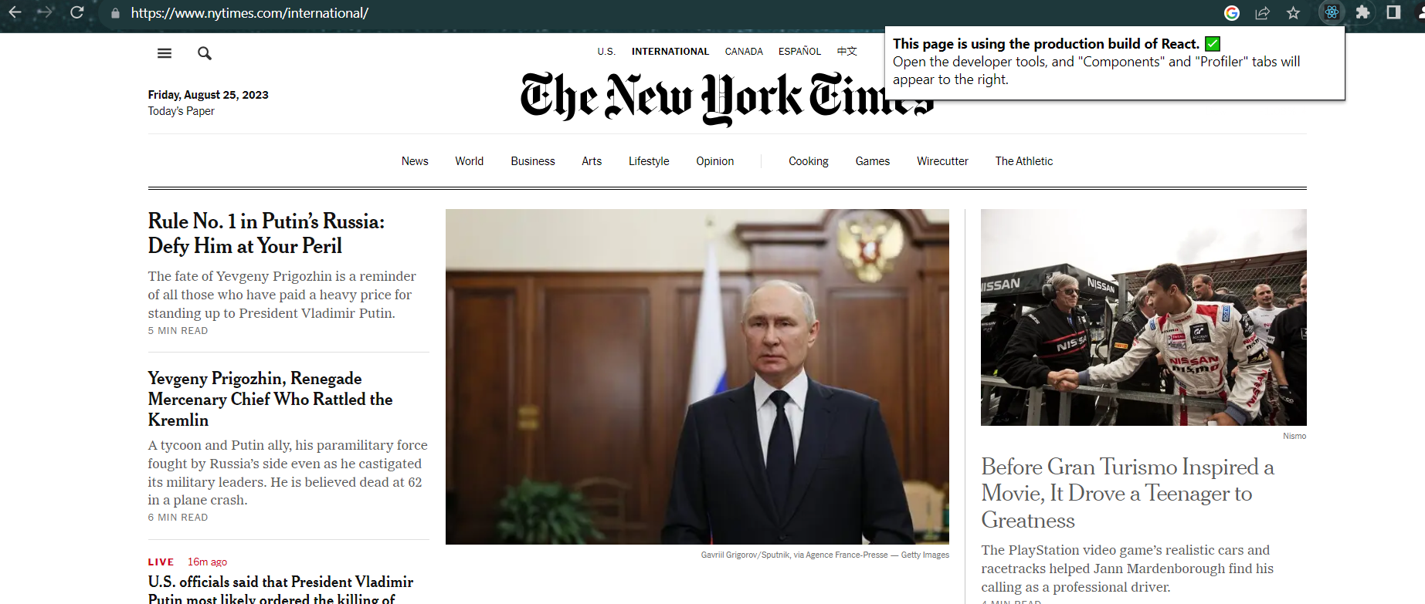

**Step 3:-** After that simple script you can write just like normal playwright test script .

Sample code:-

import { test, expect, chromium } from "@playwright/test";

test("Web Scrapping demo", async ({ page }) => {

   await page.goto("https://react.dev/");

   page.pause();

}

)

**REPORTS**

Html Reported Default:-  
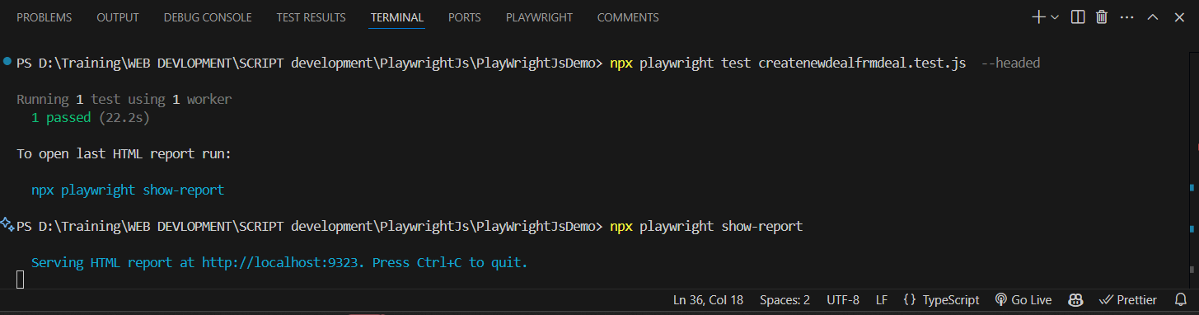

Click on the npx playwright show report  
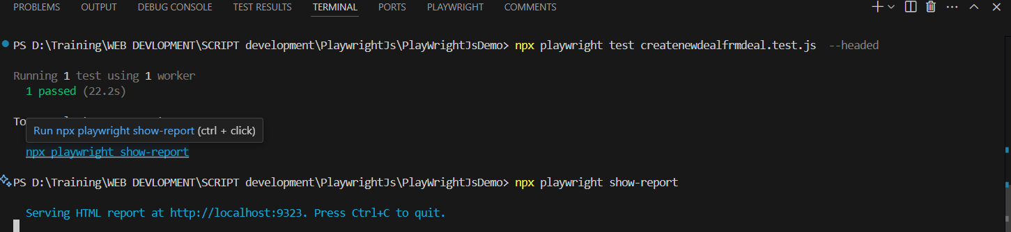  
or else run the command from terminal inside the playwright tool.



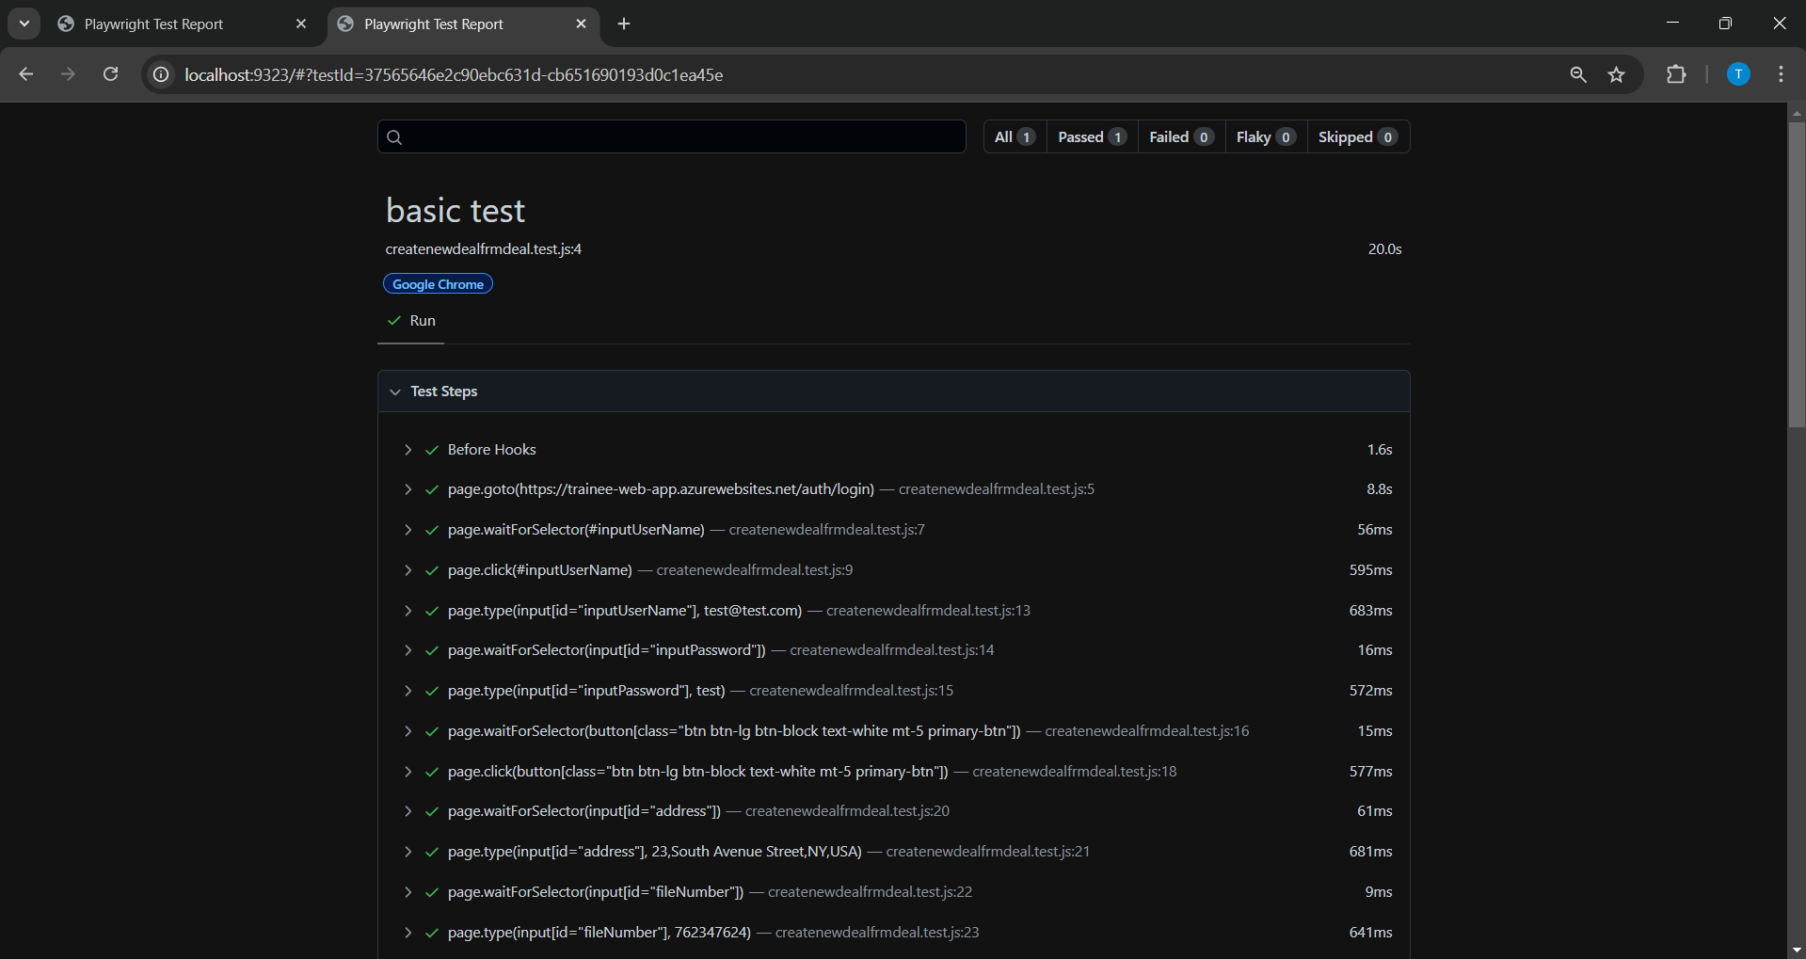

Click on Each steps expand by clicking on the each steps locators with script at what line how much time does it took for the specific

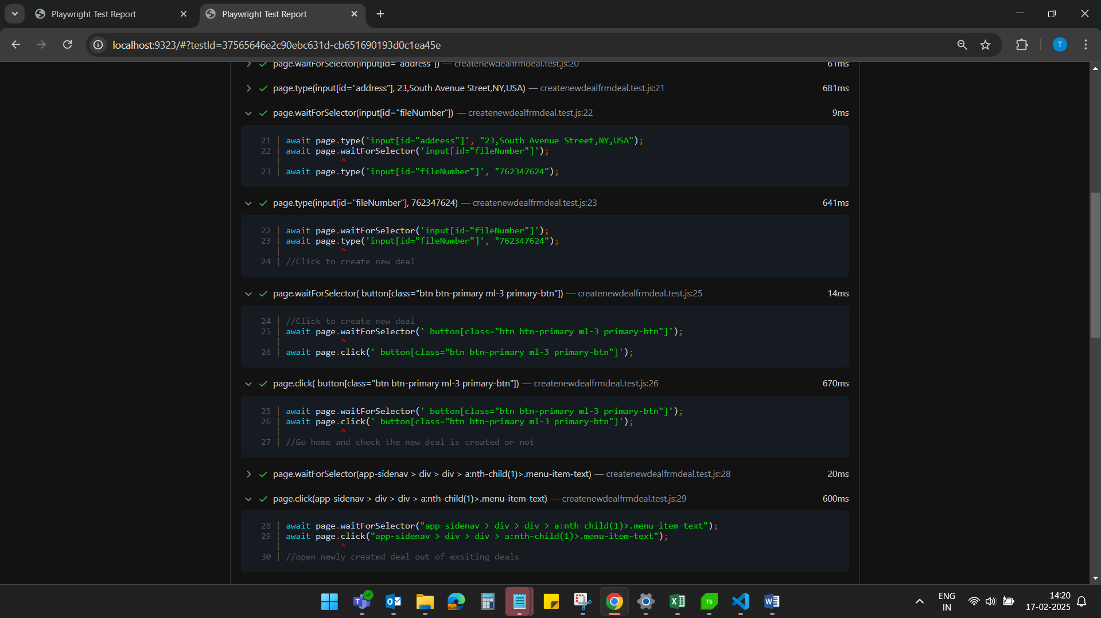

On failure screenshot :-  
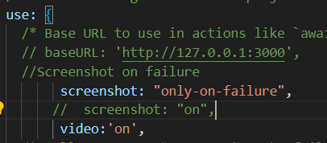

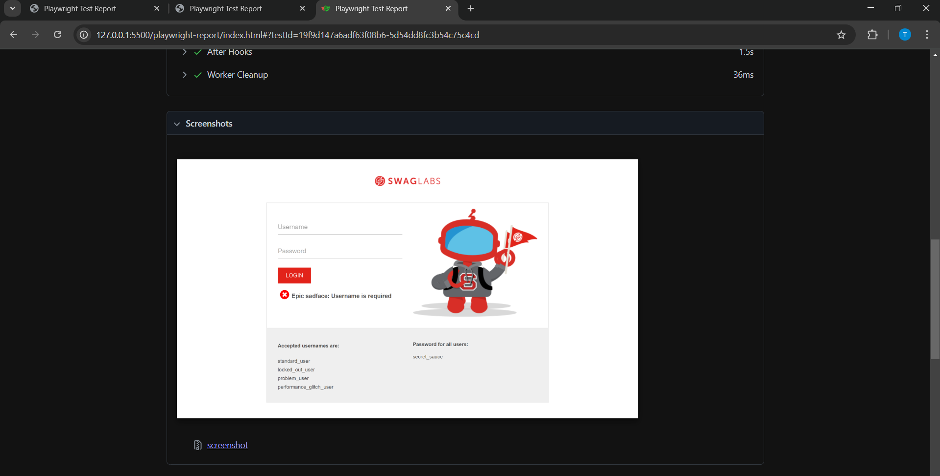

**Screenshot on pass testcases:-**  
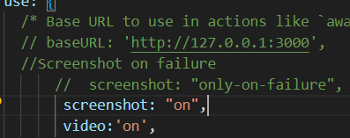

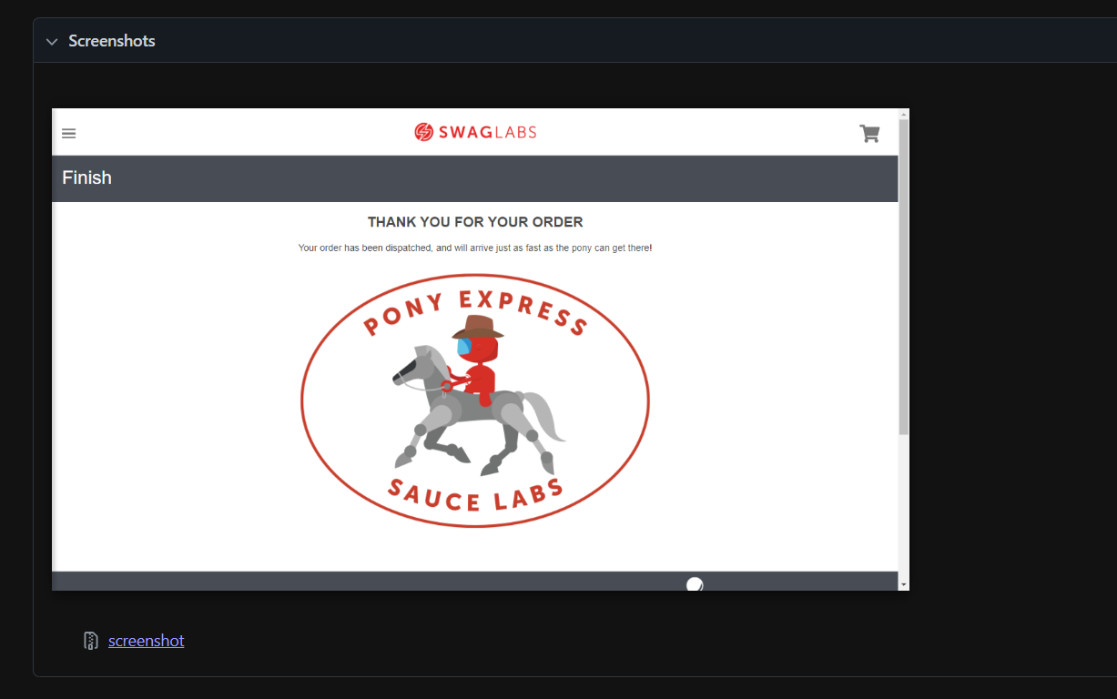

**Video also will be Recorded for automation script execution :-**



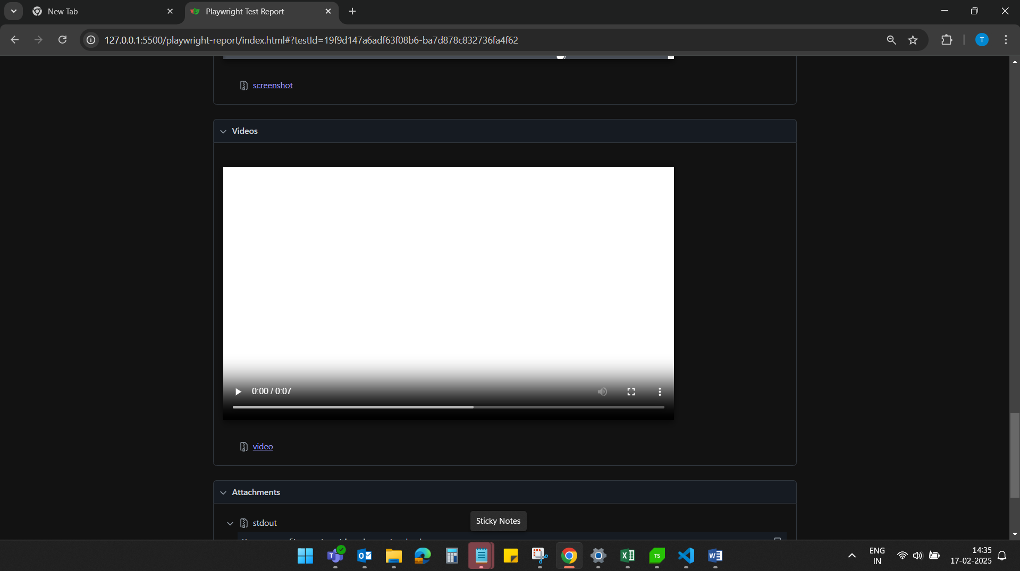

Output screen result will be also displayed on Html Report:-

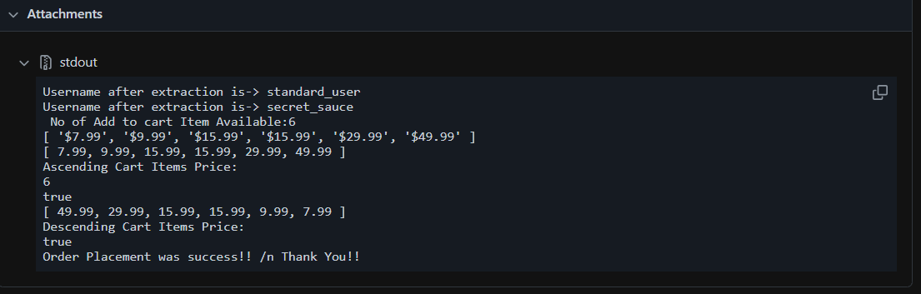

**CUSTOM REPORTS:-**  
ALURE Report :-

**Step 1: -**Visit this NPM.org website for allure Report.

<https://www.npmjs.com/package/allure-playwright>

**Step 2:-**

Under playwright.config.ts change the reporter name from ‘html’ to ‘allure-playwright ’

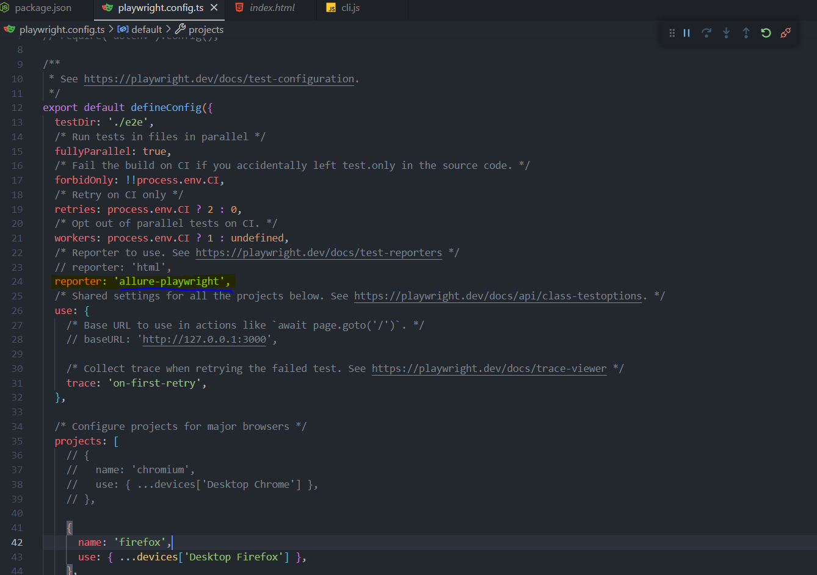

**Step 3 :-** Execute it In the command terminal :

1. npm install
2. npx playwright test
3. npm i -D allure-commandline
4. npx allure generate ./allure-results –clean
5. npx allure open ./allure-report/

**Note:-**once you executed the script then allure report will be generated in the project directory once you follow the steps mentioned commands you will able to generate and open the allure report for specific test execution.

**Please find attached allure report generation steps screenshot.**

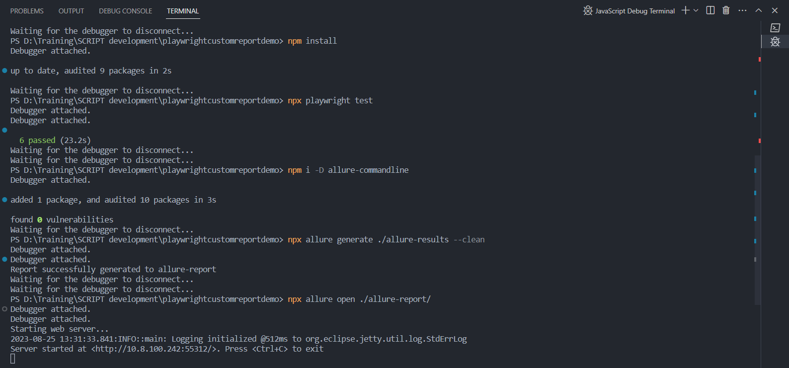

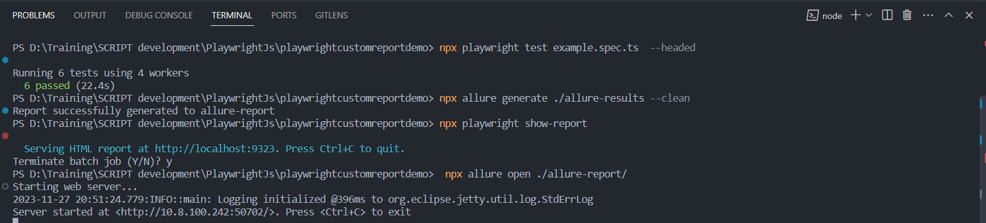

**Allure report Screenshots:**

Attached screenshot for the allure report how it looks like!!   
i) Overview of the Allure report 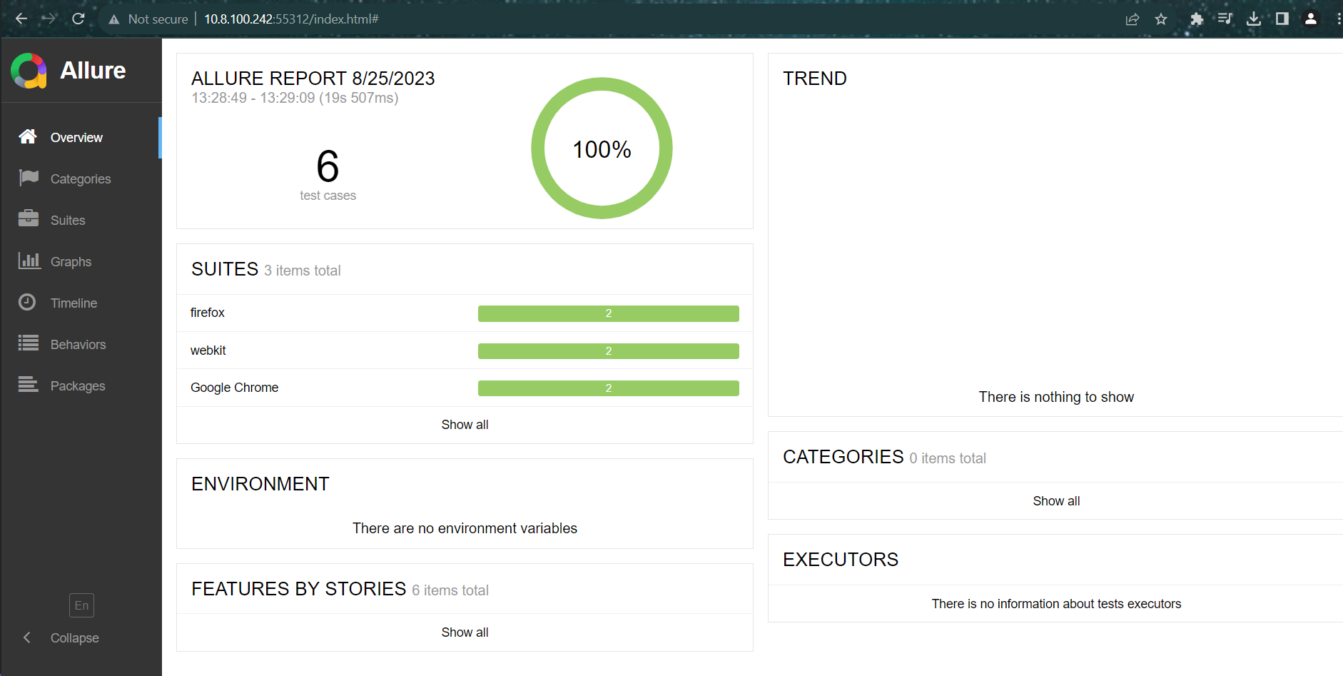

ii) Categories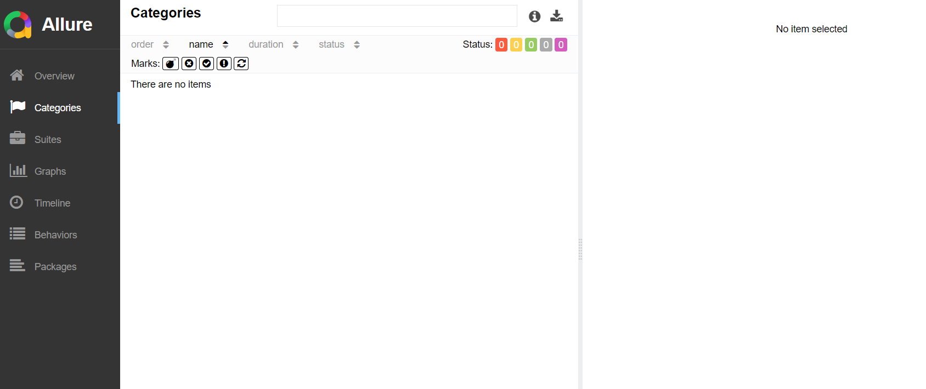

iii) Suites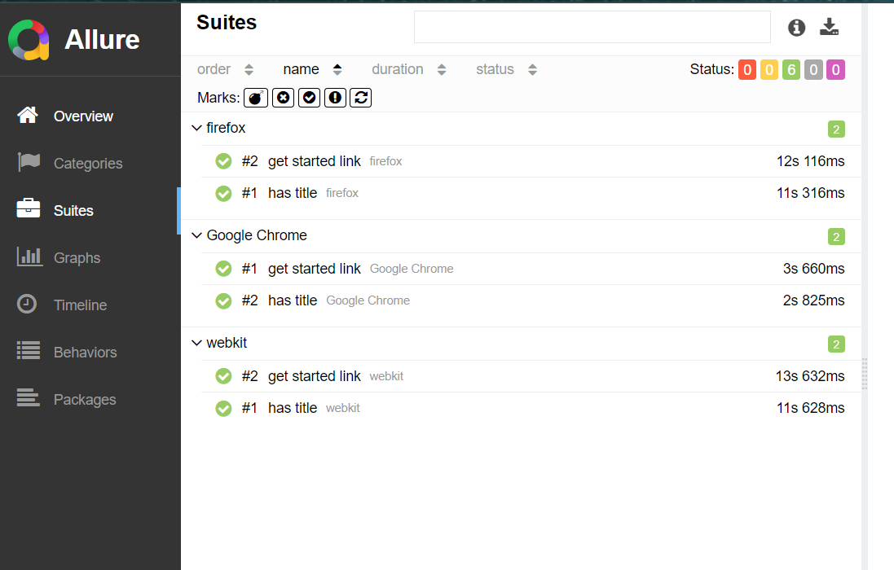

**iv)Graphs**

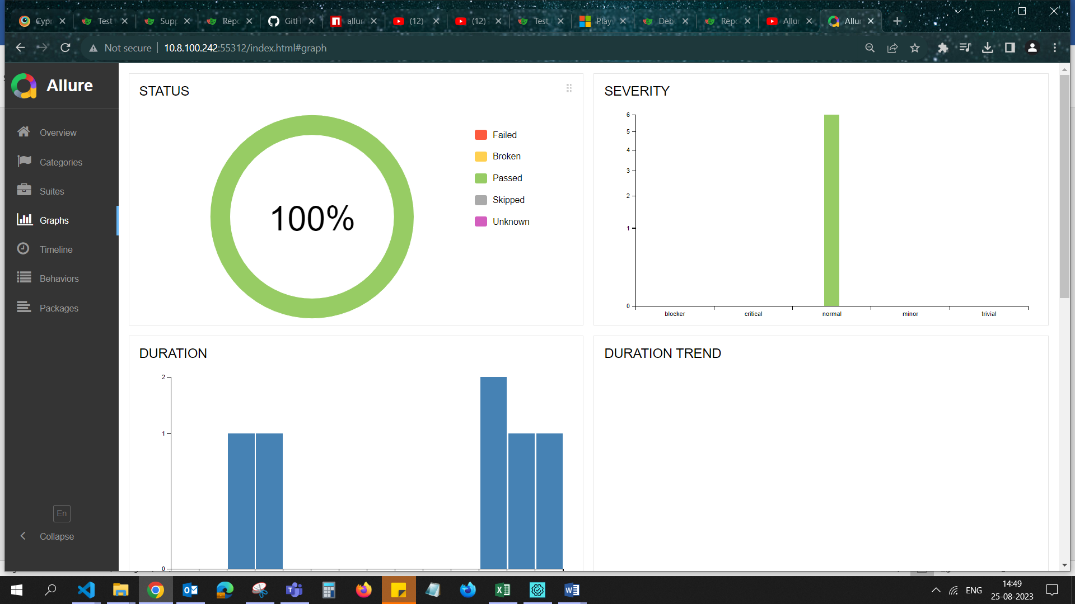

**v)Timeline**

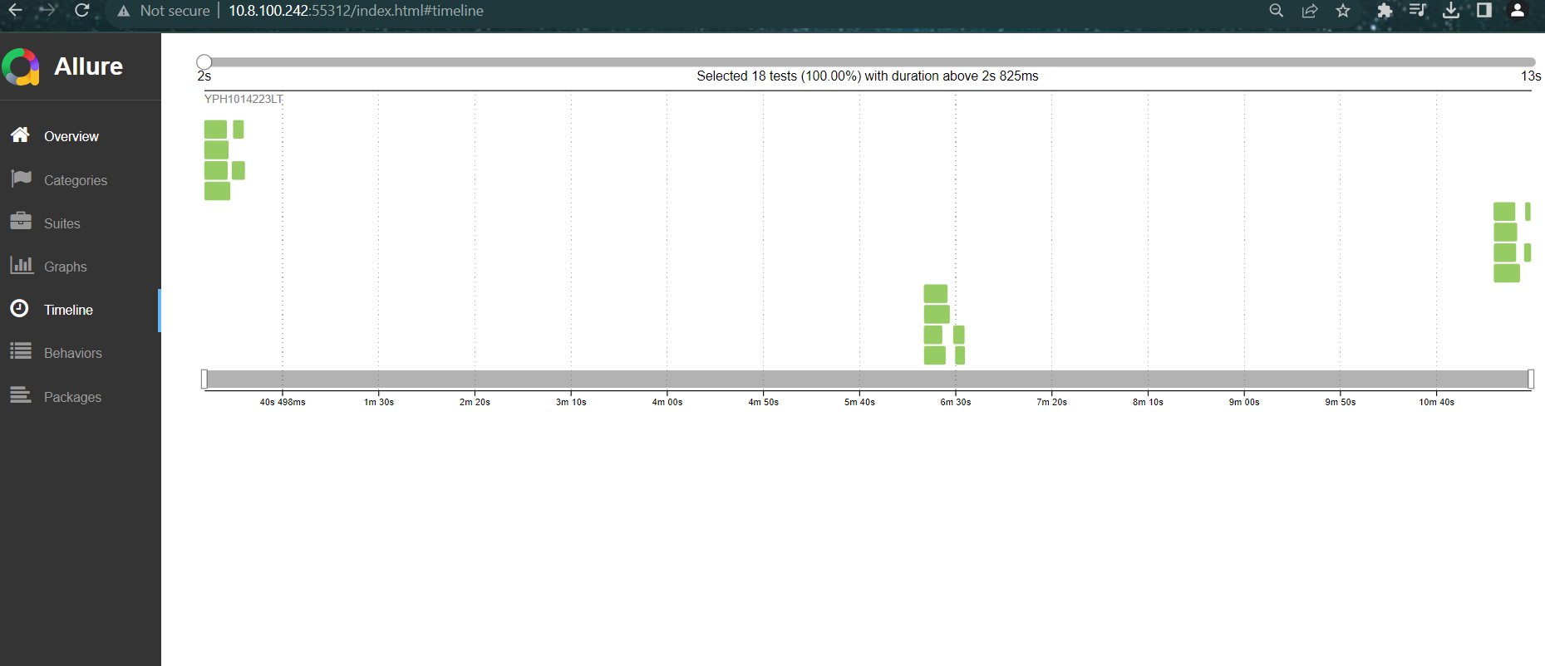

**Note:-**Other third party Custom Reports Supported By playwright JS

**Third party reporter showcase**

* [Allure](https://www.npmjs.com/package/allure-playwright)
* [Monocart](https://github.com/cenfun/monocart-reporter)
* [Tesults](https://www.tesults.com/docs/playwright)
* [ReportPortal](https://github.com/reportportal/agent-js-playwright)
* [Currents](https://www.npmjs.com/package/@currents/playwright)
* [Serenity/JS](https://serenity-js.org/handbook/test-runners/playwright-test)

Useful link:  
i) [Jest-Allure reporting plugin](https://github.com/zaqqaz/jest-allure)

ii) [monocart-reporter](https://www.npmjs.com/package/monocart-reporter)

iii)[Tesults](https://www.npmjs.com/package/playwright-tesults-reporter)

iv)[Report Portal](https://www.npmjs.com/package/@reportportal/agent-js-playwright)

v)[Serenity/JS](https://www.npmjs.com/package/@serenity-js/playwright)